May 2019 - Bed bug information and best practices

This document will provide you with general information about bedbugs, suggested guidelines for treatment, best practices for libraries, and training for staff

Bed bugs - general information about the bugs

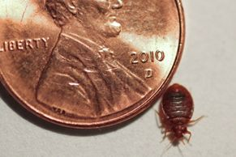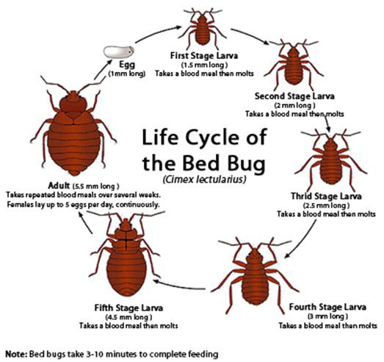

Size comparison

Bed bugs are elusive, nocturnal creatures and will hide in suitcases, boxes and shoes to be near a food supply of blood. They can hide behind baseboards and in cracks, crevices, and folded areas of beds, bedding and adjacent furniture, especially mattresses and box springs. In books they can fit into the bindings and leave markings on pages. Hardcover books are more likely to be housing them (near the spine), however they can also hide in paperback books.

Bed bugs do not carry disease; they are also not a sign of a cleanliness issue as they are attracted to blood (particularly fond of human) not filth.

Females (with access to blood and a male) will continuously lay eggs; in a span of 6 months one female could produce 5,000 offspring. Bed bug eggs can take 5 to 15 days to hatch (Murvosh, 2013) They can live 4-6 months but in some cases have lived up to 18 months (without feeding).

Evidence of bed bugs

Note the spots in the text block pictured below. This is not ink, but rather blood that has been squeezed out from the bug and it has wiggled its way through the book.
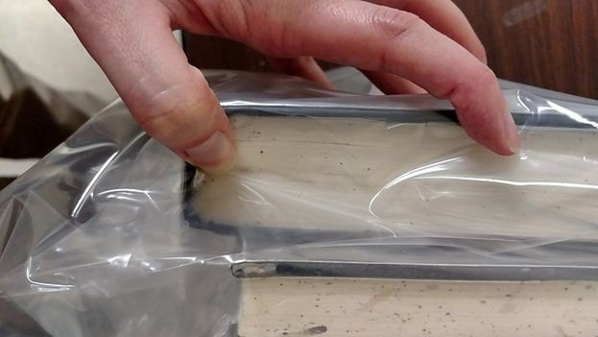

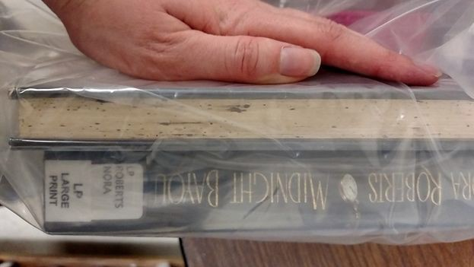

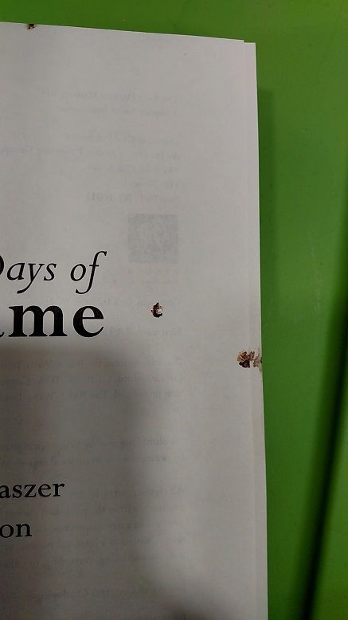
When evidence indicates a larger contamination (defined/decided by individual institutions), there are bedbugs dogs used by professionals to evaluate entire buildings.

Suggested Guidelines for Treatment of Materials

Discard:
Supervisor or appointed staff will ask for a collections assessment of a suspicious item. Popular paperback items may be discarded and collections librarians will be asked if replacement is needed. Other items will be reviewed for discard.

Pesticides:
ProZap or Nuvan strip. Place the item in a large Zip Lock bag with at least 2 inches around the book. Stand the book and the treatment strip in an upright position. Leave sealed for 5 to 7 days. Once removed from the bag, place in a well ventilated area for at least two hours. ProZap:
https://www.amazon.com/Durvet-5019510-ProZap-Insect-Guard/dp/B00061MSR6/ref=sr_1_1?i e=UTF8&qid=1483985259&sr=8-1&keywords=ProZap+Insect+Guard
Nuvan strip: http://www.bedbugsupply.com/search.asp?keyword=nuvan&search=Search

Heat and Sun:
Put all items returned in Ziploc bags and store in a warm and sunny area for 2 weeks. This will allow time for the eggs to hatch and the bugs to die of dehydration (Murvosh, 2013).

Ovens:
Purchase portable heating devices such as Thermal Strike or ZappBug Heater then heat bagged items to 125°.

Thermal Strike: http://www.thermalstrike.com/
ZappBug Heater: https://www.zappbug.com/product/zappbug-heater/

Freezer:
The use of freezing requires the use of a freezer that can reach -20° Celsius and leaving the items in the freezer for a week. The items then have to thaw and be placed back in the freezer to destroy any eggs that hatched (Murvosh, 2013).

Exterminator:
For large scale infestations of an entire building, professional exterminators have to be called in to seal the building and heat treat. This can be a lengthy process and costs upwards of
$100,000, depending on the size of the building.

Best practices for libraries

Suspicion of bed bugs in community or library
At the circulation desk:
● Examine all items, incoming and outgoing. Books, DVDs, pamphlets, everything. If you find a suspicious item, immediately place the item and courier bag in a Ziploc bag and give the item to a Supervisor or appointed staff.
● Check the record to see if there is a “damaged item” message present.
● If no message exists, create one: Possible bug damage YYYYMMDD, YOUR INITIALS
● Make the item “Unavailable” in the record
● Keep the item in a sealed Ziploc bag (double bags OK!)
● Place the item on the designated shelf or area or give directly to supervisor or appointed staff.
● Email your supervisor or appointed staff that a suspicious item is available for further inspection, discard or treatment.

Guideline for damaged library item replacement within individual library
● Individual libraries will create/follow their own replacement procedure as for any other damaged item.

Guideline for damaged library item replacement within two institution libraries
● KLE Libraries shall work with each other on a solution. Options may be but are not limited to; charge one another for replacement of damaged library item, allow treatment by library in possession, purchase replacement item, etc.
● Courier: Please be considerate of others! Please don’t send any materials that have or you suspect have been compromised by bed bugs through the courier unless they have been treated.
● If item is treated, it will be double bagged before sending back to owning library.

Addressing patrons
● Turning away patrons due to returning contaminated library items can be considered discrimination (Murvosh, 2013).
● Denver Public Library opts not to contact patrons when items are returned containing bed bugs and only notifies patrons in-person using discrete methods to protect privacy (Murvosh, 2013). Patrons are only charged if the item is intentionally contaminated or the item is damaged by attempted home treatment of the item (Murvosh, 2013).
● Wichita Libraries opt to suspend patron borrowing privileges, when items are returned contaminated with bed bugs, until the patron can provide documentation of successful treatment (Murvosh, 2013).
● Wichita Public Libraries notified patrons about the detection and treatment of bed bugs at their library using the city cable channel. The library aired a video of the library staff receiving bed bug training (Murvosh, 2013).
● Communication with the public should be calm, professional, and to the point; and should address misinformation or assumptions (Murvosh, 2013).
● Use the canines as a method of communication to help present a positive image about the treatment (Murvosh, 2013).

Prevention Tips
As presented Don’t Let the Book Bugs Bite (Murvosh, 2013), “Library directors, entomologists, and preservation specialists recommend taking the following steps to prevent and minimize library and staff exposure to bed bugs:

TRAIN STAFF All library workers and building cleaning crew should be trained to spot the signs of bed bugs and other pests. Look for pearly eggs, which are typically smaller than grains of
rice, and excrement, typically brown or black spots about the size of a pinhead.
INSPECT MATERIALS DURING CHECK-IN While looking for damage and wear, employees in circulation and shelving should watch for signs of bed bugs and other pests under the covers of hardback books, between pages, in the gap between the spine and the binding, and under the liners of CD and DVD cases. The inspection area should be isolated from shelving and seating areas.
DISTANCE YOURSELF Hold materials away from your body while shelving or processing to prevent insects from stowing away on your clothing.
CATCH LIVE BUGS Grab a zip-lock bag or a piece of clear tape to trap the insect without squashing it. Each library system should have a person designated to take the bug to an entomologist or pest control expert for identification.
BAG SUSPECT MATERIALS Seal items with problems in a plastic bag, label them, and follow the library’s procedure for treating the items. Untreated contaminated furnishings or other items should be clearly marked, even if they are thrown away.
REMOVE CLUTTER Don’t give pests any extra places to hide.
EVALUATE FURNITURE STYLES Consider replacing upholstered furnishings with wood, metal, or bed bug–resistant fabrics, such as vinyl, faux leather, or mesh.

DRYERS KILL Researchers at the University of Kentucky found that bed bugs on clothing died when put in a clothes dryer set to medium to high temperatures for at least ten minutes. Kalamazoo Public Library, MI, recommends leaving clothes in for 30 minutes.
IDENTIFY COMMUNITY PARTNERS State agricultural extensions, health departments, social service agencies and nonprofits, and preservation and conservation specialists can help provide information or resources for the library or its customers.
INSPECT BUILDINGS Libraries in urban areas or bed bug hot spots might consider having a bed bug–sniffing canine check out each building monthly, bimonthly, or at least quarterly, depending on the risk in the community.
PROVIDE INFORMATION Select the top few best resources for community members and post them on the library website, along with directions for materials return if patrons suspect they have a bed bug problem. Locate, organize, and distribute additional resources for staff needs. Include “refer patrons who need more detailed information to the reference librarians” on the resource list given to all staff, and make sure the reference librarians have those more detailed resources at the ready.”

Works cited

"Bed Bugs." EPA. United States Environmental Protection Agency, 19 Dec. 2016. Web. 9 Jan.
2017. <https://www.epa.gov/bedbugs>

“Bed Bug Dogs.” Bed Bugs. http://www.bedbugs.org/dogs/

Murvosh, Marta. "Don’t Let the Book Bugs Bite." Library Journal. 24 July 2013. Web. 09 Jan.
2017.< http://lj.libraryjournal.com/2013/07/lj-in-print/dont-let-the-book-bugs-bite/#_>

Potter, Michael F. "Bed Bugs." Entomology at the University of Kentucky. University of
Kentucky, May 2012. Web. 9 Jan. 2017.
<http://www2.ca.uky.edu/entomology/entfacts/ef636.asp >.

* Heavily borrowed from MOBIUS “Bed bug information and best practices.” March 2017.

